3D Vision - Lab 1

Student Names
Student IDs
Group

1. Planar Transformations

1.1 Applying homography to an image
You have implemented the apply_H function to apply a homography to an image.

What is the 30º rotation matrix, H, that you selected, and what is your rationale for this choice?

Paste the image output displaying both the original and the rotated version.

What type of transformation is H, and what is the reasoning?
How many degrees of freedom are associated with this kind of transformation?

1.2 Decomposing of a transformation
Now you have to apply the following transformation to the Mondrian image:
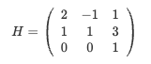

Regarding this new homography, which kind of transformation is it? Why?
How many degrees of freedom have this type of transformations?

Paste the output of the image showing the original and transformed image.

Which are the matrices corresponding to each one of the transformations?
Which is the appropriate order of composition?
(You can write them down or take a picture of your theoretical solution)

Paste the plot showing the image transformation step by step.

Do the sequence of transformations look right to you? Why?
(Don't worry if there is a translation difference in the last image)

Paste the plot comparing the image transformed with the original matrix and the one transformed step by step.

Do the original and transformed image look similar? (Don't worry if there is a translation difference)

2. Image Rectification

2.1 Direct Linear Transformation (DLT)

2.1.1. Interactive method
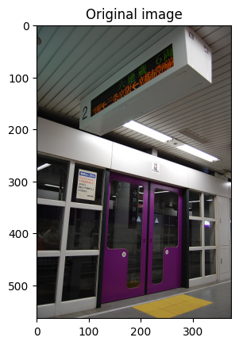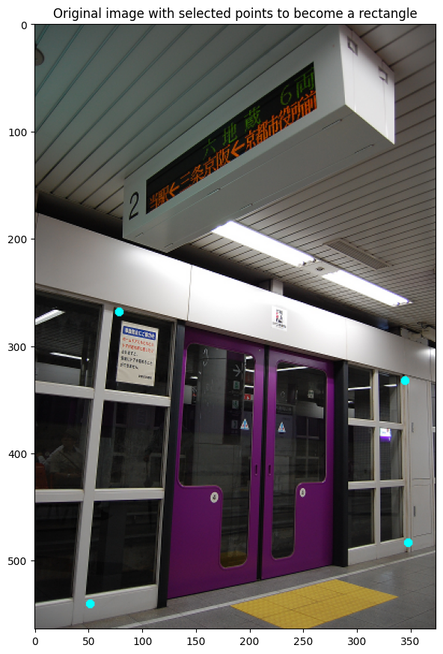

Paste the transformed image. | How does the DLT algorithm work in this example? Explain it briefly with your own words.

2.1.2. Rectifying a picture of a paper
Paste:
- The image with the corners selected
- Transformed picture
- Cropped picture

- Paste your obtained 3x3 homography matrix.
- Identify the transformation type (Projective, Affine, Similarity, or Euclidean) and state its Degrees of Freedom (DoF).

Regarding the DLT estimation
- How many point correspondences are required for this type of transformation? Why?
- What would happen if we had less?
- What would happen if we had more correspondences?

2.2. Stratified method
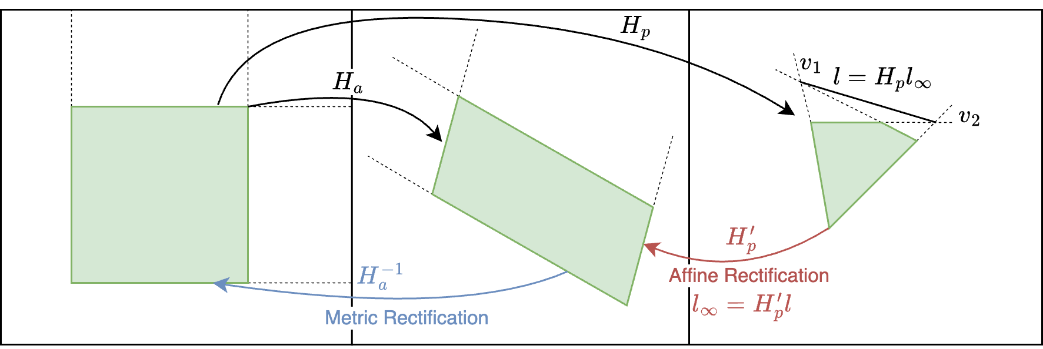

2.2.1 Affine rectification
Paste the image with computed lines and points.
- Where are the vanishing points? Paste their coordinates and interpret them. Do these vanishing points fall within the boundaries of the image?
- What are the desired locations for the vanishing points after affine rectification? What is the rationale behind these target locations?

Paste the affine rectified image.
- Write the obtained rectification matrix. What is the interpretation of the last row of the affine rectification matrix?
- What’s the result of applying the homography to the line joining the vanishing points?
- What’s the result of applying the homography to the vanishing points?
- Which is the geometric relation of each pair of lines before and after the transformation? (i.e., l₁ with respect to l₂, lr₁ with respect to lr₂, and so on with 3 and 4.)

2.2.1-B) Semi-automatic Affine Rectification

Indicate the pair of vanishing points chosen to affinely rectify the image. Justify why you have chosen these vanishing points

Paste the rectified image with this method | Do the image and the obtained homography matrix look like the previous one? Why?

2.2.2 Metric Rectification

Paste the obtained transformed image.
Explain your solution.
- Paste the obtained 3x3 homography matrix and explain its values
- Which kind of planar transformation is it? How many DoF?
- Explain how the image was transformed.
- What's the value of the transformed vanishing points?
- Does your solution work? Why?

3. Image mosaics
Original images:
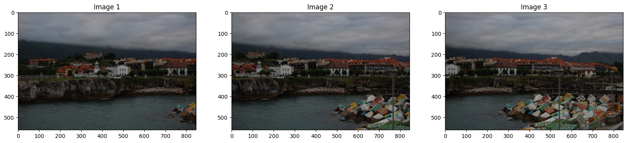

3.1. Image correspondences

Keypoints of images 1 and 2 Keypoint matching between images 1-2
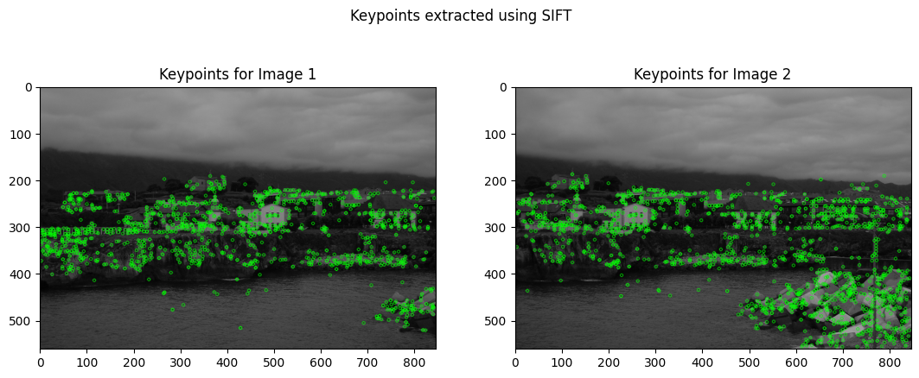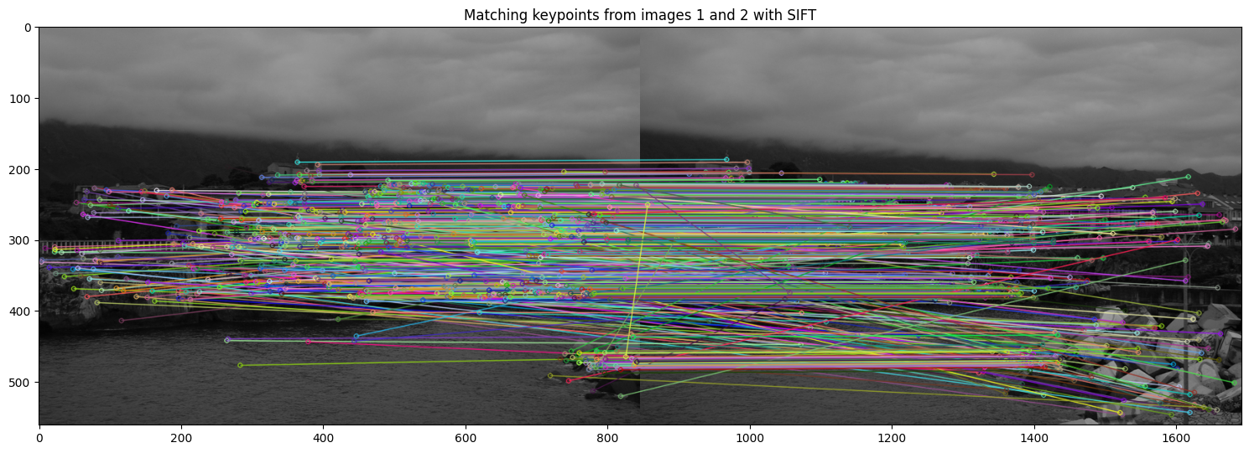

Paste the keypoint matching between images 2 and 3.
Explain the result after applying keypoint matching.
- Are all the matches correct? Why?

3.2. Compute the homography
- Briefly explain how RANSAC DLT Homography works.
- What is s? Which value have you selected for s? Why?
- What is th? What are its units? Justify the chosen value.

- Explain how the adaptive loop works and the differences with the previous method.
- What happened when comparing the adaptive loop with the fixed loop?
- Which algorithm would you prefer? Why?

Paste the inlier correspondences for image 2 and 3.

Interpret the obtained homography matrices.
- Paste the values for H_12 and H_23.
- Which kind of planar transformations do they apply?
- How do they transform points from one image to the other? In which direction? Write the equations.

3.3. Build the image mosaic
Paste the mosaic obtained
- Does it look right to you?
- Which homography is applied to image 1? Why?
- Which homography is applied to image 2? Why?
- Which homography did you choose for image 3? Why? Is the direction of the transformation correct?

3.4. Build your own image mosaic
- Explain the process followed to build the mosaic
- Did it work as you expected? Did you encounter any issue?
Paste the original images and the resulting mosaic.

AI usage reflection
We want you to use AI responsibly, and reflect about its usage in an honest manner.

- Which AI tools have you used? (ChatGPT / Copilot / Gemini, embedded in Visual Studio, Cursor, etc)
- For which tasks have you used these tools? (Debugging, writing code, understanding concepts)
- What does the tool succeed on?
- What does the tool fail in?
- Have you used these tools previously? How?
- Do you think they help you in the learning process?
- Feel free to write your opinion about it.

Provide screenshots of the prompts you used and the resulting output from the tool:
- Successful Example: One instance where the tool significantly assisted you. Justify its success and usefulness.
- Failed Example: One instance where the tool did not perform as expected. Explain the reason for the failure.

Self-awareness

- Provide an overall explanation of the lab. Describe the goals of the lab clearly. State the problem you were trying to solve or explore in this lab.
- What have you learned? Did the lab help you visualise and understand concepts?
- Which parts of the notebook did you succeed in? Describe the sections where you felt confident, and explain why you think they were successful.
- Which parts of the notebook did you fail to solve? Be honest about the areas where you faced difficulties. What challenges or issues did you encounter that you couldn’t resolve? How would you approach these issues in the future?
- Are there any concepts that are not completely clear yet? I.e., if you were asked about your submission in a 5-minute interview, what question would you least like to be asked about?

Extras
Add extra results below.

